One day delivery

Cosmetics is still good on high-street

Online adapts quicker

20-30 year old have more disposable income

Less are buying houses

Hire millennials / generation z

Retailers need to adapt to the demands of shoppers to avoid casualties by creating hyper-personalised experiences. The gap between online and in-store needs to be closed so having an experience that merges qualities of the two is the solution. Existing Ubamarket research has found that 17.5 million shoppers want app consolidation, meaning that they want one app for the end to end of their supermarket shop. The shoppers also stated that they want purchase, loyalty schemes and live-offers all under one app. Having to do this on separate apps would hinder them from returning to use a number of apps again.

Onbuy.com over 12 million products online

Never competes against sellers

October 03, 2018

Death on the High Street? How e-commerce and social media are changing the way we shop



Written by [Neil Ackerman](https://theleadershipnetwork.com/user/33735)

Senior Director, Global Supply Chain Advanced Planning   
Johnson And Johnson

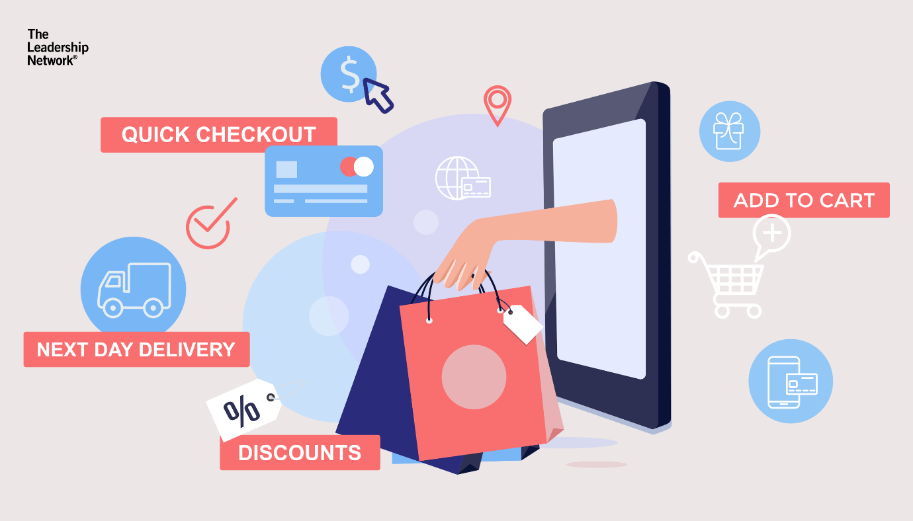

Western society is on the verge of a revolution in the way we shop. The death of bricks and mortar shops has been talked about for many years. Neil Ackerman is Senior Director, Enterprise Supply Chain Global Planning and Innovation at Johnson and Johnson, a multinational manufacturer of healthcare products. Neil also has years of experience at Amazon.com with many patents to his credit. He explains the major changes occurring right now in retail, why agility is the most important muscle to develop, and why he is convinced that in 20 years’ time there will be fewer high streets.

Most new technologies change our lives. However, many take many years to affect everyone for reasons of cost, willingness to change habits, and a reluctance to do things differently. The difference now is that pressure on global economies, real estate fluctuations, environmental policies, and the collapse in recent years of many well-known retailing giants is forcing the inevitable – the decay of the high street.

The decline in traditional retailing has been talked about for decades. Many people say it won’t happen because walking round shopping malls is a hobby for many people. Clever merchandising combined with events for kids is encouraging many consumers to buy impulsively happily paying higher prices for things they could buy much cheaper online.

These trends are likely to continue for some time but like the quill pen traditional retailing will decline. Direct to consumer is here to stay. Amazon’s e-commerce sales are a clear indication of that. Total US Amazon retail e-commerce sales (gross merchandise value) are expected to hit $258.22 billion in 2018, up 29% over 2017—far exceeding total US retail e-commerce's growth of 16%.

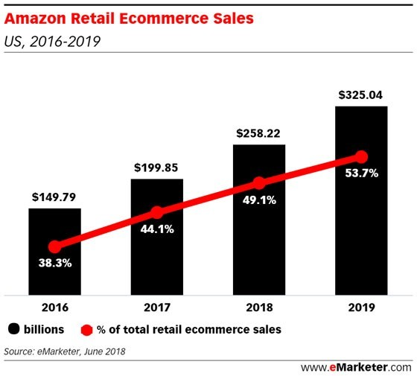

The latest eMarketer forecast shows that Amazon continues to set the pace for US retail e-commerce and will account for more than 80% of the overall market’s expected growth this year.

Protectionist policies like increasing the tax burden on internet giants like Amazon will fail. Also, wily entrepreneurs who can make quick profits by exploiting current supply chain inefficiencies are likely to be around for a few more years – but their days are numbered. It is about the long-term game. The most exciting start-ups are focused on many technologies and services that are initially misunderstood followed by the “light bulb” that goes off in everyone’s head when they see the benefit and love the invention. Nothing is more exciting to watch!

Consumers always want lower prices and they always want more solutions. A consumer doesn’t wake up one morning and say “I want to pay more”. Seamless integrated 24x7 e-commerce solutions are now being implemented. Seamless 4G is the norm in most major cities and towns in the Western world. Soon powerful 5G networks will be available. Increasingly consumers expect to pay less for access to networks that work wherever they are – underground or in the air.

Another major force is that e-commerce and social media are coming together to create truly integrated networks with considerable opportunities to gather data about the way we buy. Some companies will not share data because they do not wish their competitors to obtain an advantage, but models are evolving to overcome those obstacles. In truly integrated solutions functionality is one ecosystem. The rapid growth in artificial intelligence and the use of algorithms is making it much easier to integrate functionality. It is not just machine learning that create an advantage, it is the ability for the curated and un-curated data to work together to form detailed recommendations for next steps in the end-to-end supply chain. That is the magic.

It is time to change. Manufacturers should no longer feel constrained by the length of the aisle or pressure on margins dictated by global bricks and mortar retailers. The future is all in direct to consumer and those who figure out the most effective and cost-efficient supply chain with fast delivery and low prices will win. The new game has begun. Jump in! The agility required to be everything to everyone drives who wins at the end. The focus must be on personalization, targeted precision and amazing product consumer centric benefits. It is a high-bar but those who capture it online and at retail win eCommerce and the High Street. The great unlock is your supply chain which now goes from a cost center to a revenue generating machine. I call it Magic By Supply Chain and Houdini better watch out.

This entry was posted in [Supply Chain Management](https://theleadershipnetwork.com/articles#supply-chain-management) and tagged **How ecommerce supply chain works,** **How ecommerce improve supply chain management,** **How does social media affect supply chain management,** **High street decay,** **Johnson and Johnson** on October 03, 2018 by [Neil Ackerman](https://theleadershipnetwork.com/user/33735)